It is a cold and rainy November night; the cold winter air is flowing through the narrow slits of the windows in a white delivery room. A small person is lying on the chest of a man. The day in question is my birthday. I was born 2920 hours early, four months to be approximate. The chances of survival for a such early born child are less than one percent. A body height of not even thirty centimetres and weighing only nine hundred thirty-five grams, it was a real miracle I survived the delivery. The doctors told me I would be mentally retarded and not able to do sports in my life, ever. – instead I was offered a full scholarship for private schooling by Mensa and was northern German traditional boxing champion and rowed for the national team of Hamburg. – I was born.

Consulting my cultural background, I am half German and half Chinese, where I actually see cross-overs in aspects from both sides. I identified myself as being low context, being clear in what I say, without a lot of waffle. On the other hand, the Chinese side of my heritage tends to take control whenever it requires me to be detailing and descriptive. Hence, most of the time, when a given task is clear, my arguments are understandable without providing measures of background information with cultural context. Examples of needing provision of background information can mostly be found within the unique idioms a language has. Cross cultural communications class, allowed me to further investigate and more importantly, understand the fact, that my behaviour is stronger and deeper defined by my values than I thought it would be. When consulting Hall´s Iceberg model I certainly do agree with the fact that the model illustrates the behaviouristics of an individual. The behaviour being the tip of the iceberg, breaking the figurative surface of one self, and my beliefs/values, defining me, being the hidden and major part of the iceberg. Considering Geert Hofstede and his models, I can identify myself as highly individualistic and non-indulgent as the most extreme poles of the six dimensions of his model defines the personality and character forged from the cultural background. My father is Chinese and my emotional and intellectual connection is stronger with him, relative to my mom, in every way. Hence, My culture is more likely to be strained with his traits and values, which I inherited by being raised, rather than those of my mother. Just like my father, I share the same extreme individualism and low-context traits with him, compared to my mother, who is very high-context and collectivistic. Considering Hofstede again, and this time, consulting the values that define a character, mine are also clearly in majority inherited. Only a very few, have in fact established themselves and actually remained themselves over time. Further explaining my point, over ninety percent of my values are inherited. In contrast with my cultural traits such as the six dimensions, my values have been forged by both parties that raised me. In fact, the tendency lies to be, that my mother bequeathed the majority of my values. That might be due to the fact, that my father only values a very few values in his life, whereas my mother values a vast number of them. The values that reinforced themselves are respect, not only for people around me, but rather life at its whole, and furthermore non-living bodies. Another value I am most certainly paying attention to, is dedication to myself.

That value is actually forged and reinforced by my Chinese grandmother. Every person has this grand-parent, that gives important life-lessons, repeatedly. “For everything you know, only you exist, and that is why you should always 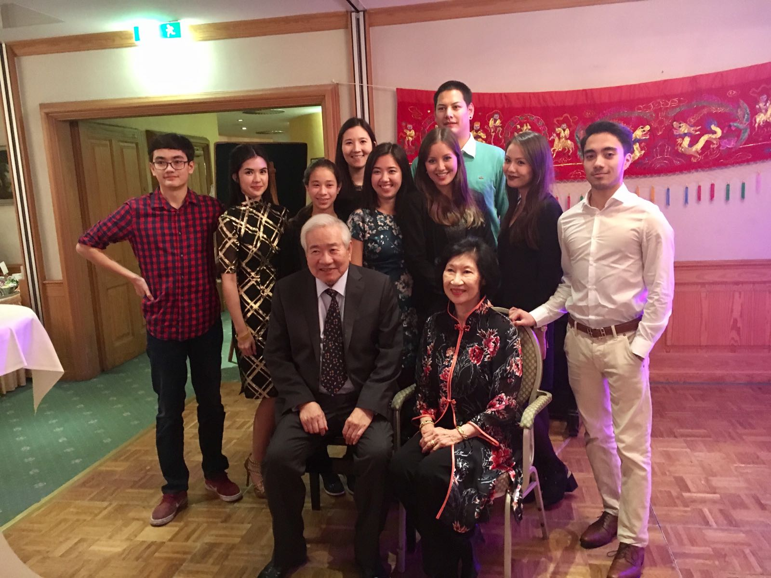ensure for yourself first.”, so my grandmother always. (of whom I actually don´t even know the first-name of) These values determine deeply how I feel and think about another person. If one is relatively disrespectful, even just so slightly, to the environment around him or damages the society, he will have no right to consult me in any means. Human nature is destructive, it was always easier to destroy than create. That is another value that I look out for, being “homo faber” translating roughly to “man the maker”, “the creator”, creating things instead of destroying. Hence, if human nature is essentially tending to be destructive instead of creative, the imminent destruction of ourselves and our environment is destined to occur. Therefore, it is crucial for every individual and collective to restrain their most human nature and rather advance the beings of man. Striving for more and not stopping at the limits of the imaginable is a way of thinking I support. There is no limit, if you push the limit further and further. In the most literal sense that is the case. The common conception about the universe it that it is endless, but that is not actually the case, the universe is expanding at an accelerating rate. Therefore, it is figuratively endless, in the means of we can never physically reach its end, but chase the limit of everything. One of the greatest person living today on earth, is Elon Musk. He shifts the paradigms continuously and therefore literally pushing the limits beyond its limit.

The youngest „Yiu“ generation learning important lessons about life from the oldest generation.

My values and beliefs do really influence my character the more I analyse and reflect on them, it seems like predetermination, but only, and very luckily, seems so, instead of being the case.

So much to the self-evaluation of my cultural background, as I would most likely spend pages more analysing, reflecting and extrapolating.

How do I interact when experiencing a culture-clash? – When consulting Neuliep and his contextual model of intercultural communication, it is clear that intercultural communication has many opportunities to fail. Culture clashes in form of cultural shocks happen all the time, their sources might be their values (Hall) or their cultural heritage (Hofstede).

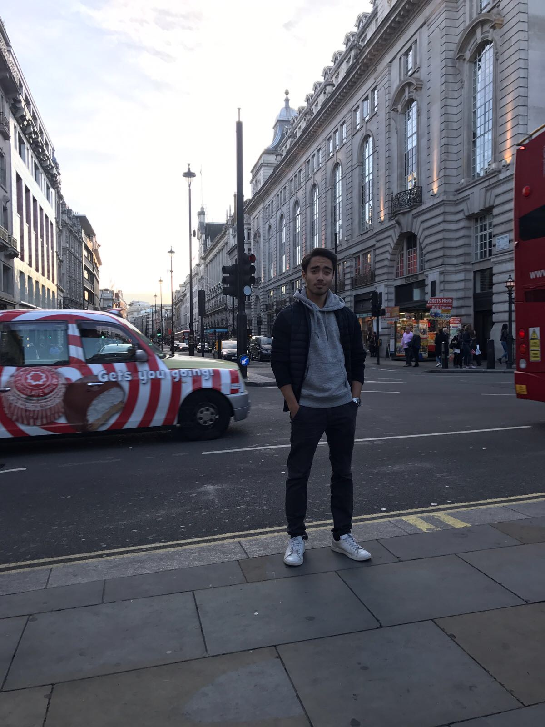When first arriving in London, I had the conception of London being how it is portrait in media, completely different how it is in reality. As discussed in class, the biggest misconception was most likely to expect British people running around, whereas the majority of London´s population is immigrated. Cultural clashes in form of having two or more super-cultures colliding and having one or multiple dominant cultures penetrating the less dominant cultures is clearly visible in nowadays immigration rise. When taking Germany as an example, there are millions of refugees from surrounding countries seeking refuge in Germany and often culture clashes arise. The culture immigrants inherit is often dominated by the German culture, because of the environment they find themselves in. Refugees and immigrants are often wanted to adapt themselves to German culture and give up their inherited culture. Whether or not that is an offense against the very means of culture is not my call to make, but definite is, that cultural clashes often lead to the destruction of one or multiple. In some rare cases, in the example of Germany, culture clashes don’t have to be destructive, rather symbiotic or even evolutionary. In the very sense, that a new sub-culture arises from two super-cultures or two super-cultures not being able to sustain themselves without the other. In Germany as a specific example, Towns arose, that relied on the refugee´s culture being sustained. Germans for example like the Turkish food and hence, in some places there are only Turkish restaurants. New neighbourhoods arise and form beautiful new sub-cultures, aspiring new generations to prosperity instead of destructivity. 

Two turkish women at a local german market. The area is as cultural diverse as possible, and their cultural co-existence vital.

The behaviouristics inherited by my cultural heritage restrict me in some ways. A perfect example is when being in an environment of a highly collectively cultural group of individuals. Often my extreme individualism restricts me of being completely integrated into a community with said trait, as I cannot fully grasp their behaviours. Collectivism is a concept that is surreal and rather ideologist, comparable to a utopia. The ultimate and essential success of human nature is a perfect collectivism, but as clearly a perfect collectivism cannot be achieved, I completely abandon that belief of achieving any level at all. I am a person that values enforcement, in the sense of, either doing something the way it is theoretically intended to or not doing it at all.

People around me and myself tend to say, that I am unlike any other young man they ever experienced to be in contact with.

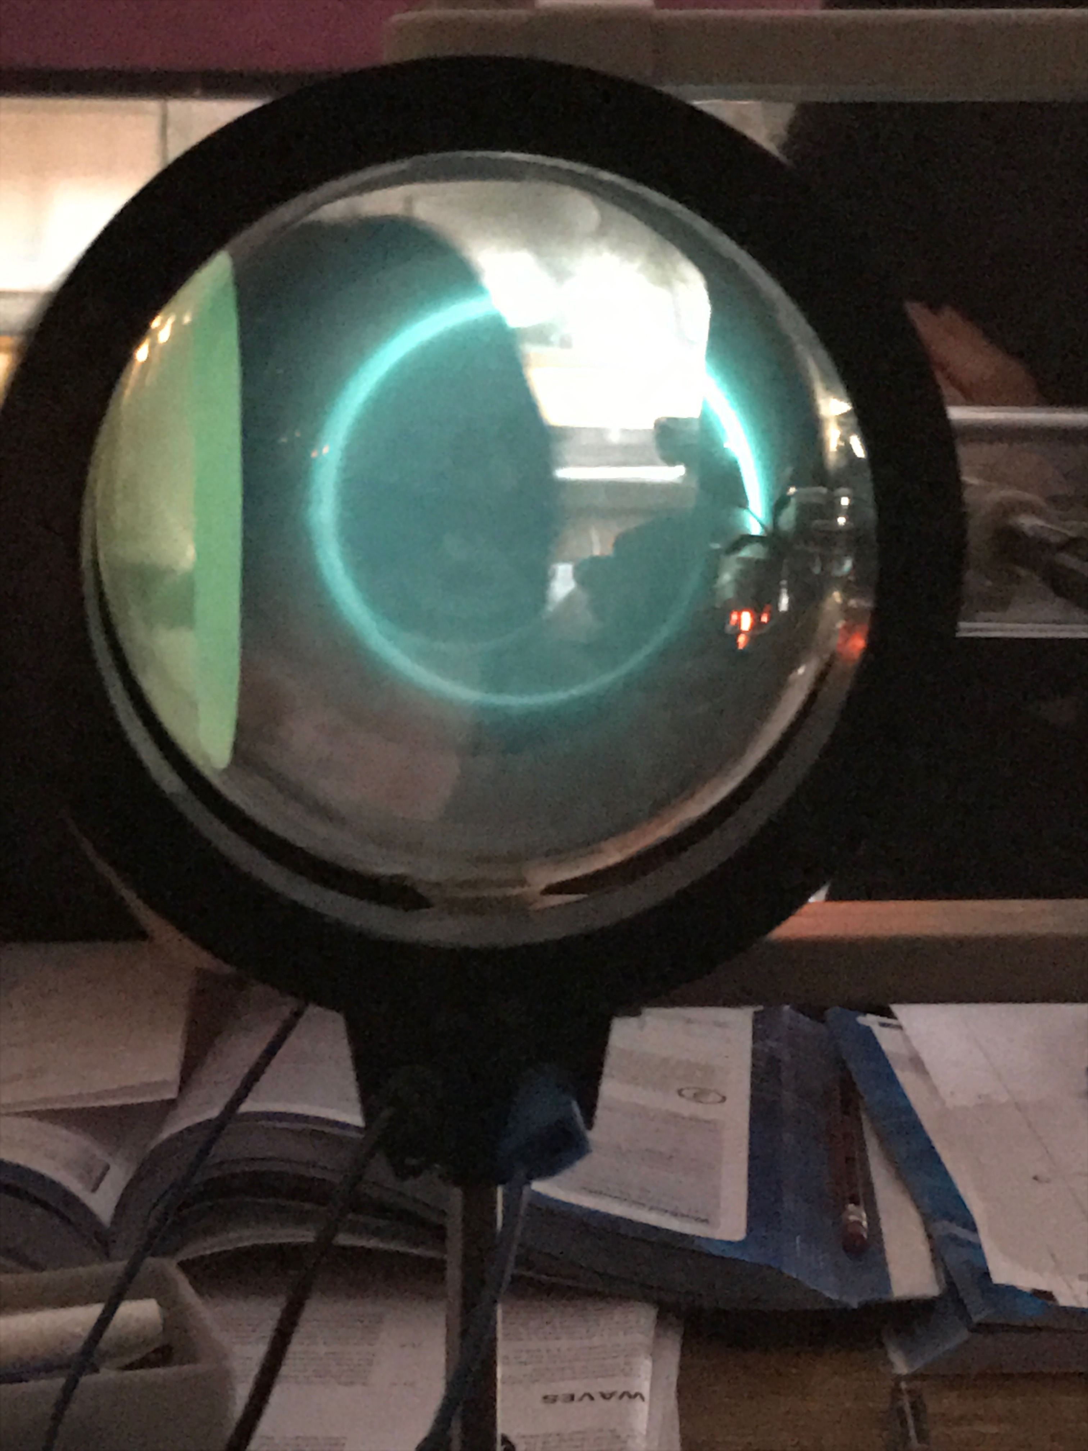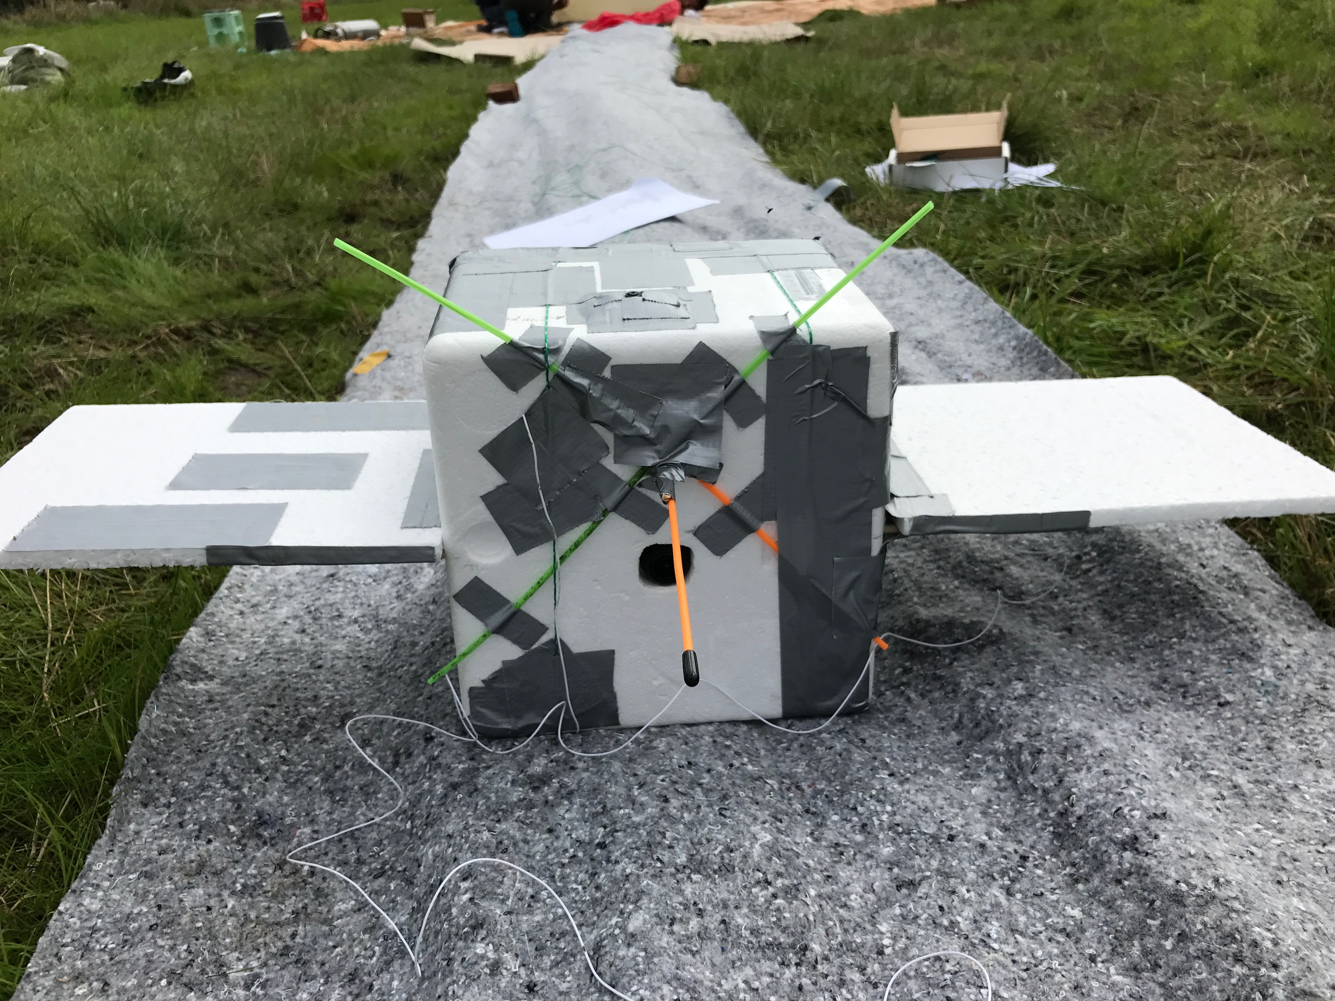Maybe that is the case because I like to build weather balloons and send them thirty-eight kilometres high up into the stratosphere to collect data and take photos, or maybe because nearly blew the house up while trying to figure out the difference between fission and fusion reactors when I was fourteen. Anyways, I do unusual things in my free time, because normality is the one thing I fear more than anything else. Normality leads to identically individuals, (which is not possible) and defies the purpose of life. Hence, whenever I see a trend arising, I walk the other way, figuratively speaking, to not be associated in any way with certain trends. A good example of what I try to illustrate, is the book 1984 by George Orwell.

The drone that took the astonishing picture seen above in over 38km height.

The problem with putting people into boxes, which of course we all do, certainly every time we think about other people, is that there are sub- and super-boxes. Meaning for every box a person is being put in, there are more than two infinite other possible boxes created. Infinite boxes for infinite starting points, for infinite developments/outcomes and infinite possible variations. The concept is based on the many worlds theory, and basically describes a snapshot. If you have an apple, there is another version of you holding an apple that is green instead of red, there will also be a version that has a pea instead of an apple, or a cherry, in some of those infinite possible versions you eat the fruit, if even a fruit, in some you toss it. In some of those infinite possible variations you like the fruit, in some you don’t, in the infinite possible variations, in which you tossed the fruit, you might re-think your decision and pick it up again or get something else to eat, hence you might like that or you wouldn’t. That repeating, but at the same time not-repeating concept can be applied to any possible situation and hence nothing matters, because everything is and isn’t.

Me inducing a magnetic field and „bending“ light

Being able to understand how things work is not desirable, in fact, I wished I wouldn’t be. Simply because, after thinking more and more about every single thing that might be or not be or could be, you start to realise that nothing matters. It is really hard to not give in, to the belief that everything is nothing in the relative terms of everything.